Author Guidelines
Manuscript format
The English manuscripts published in the proceedings must be written in “Times New Roman” font of 12-point type. The required font type must be used along with double spacing between lines of text, and continuous line numbering along the margins of the manuscript. Manuscripts should not exceed 12 pages. Submission files should be in Microsoft Word.
Please follow the guidelines below for an appropriate munuscript.
Research paper manuscript
The manuscript will be composed of the following;
- Title: A title with the first word and proper nouns capitalized.
< Centered bold, Time New Roman 14, Single space >
- Authors: Full names (given name, middle initial, family name) of all authors.
< Centered bold, Time New Roman 12, Single space >
- Institutions: Institution name, province/state, and country. The institutions of the authors with location denoted with a number (1, 2, and 3) behind the author’s last name.
< Centered italic, Time New Roman 12, Single space >
- Corresponding authors: An email address of corresponding author
(Left, Time New Roman 12, Single space)
- Abstract
< Left bold, Time New Roman 12, Single space >
- Body of Abstract
An abstract with a single paragraph of no more than 300 words that should state important objectives, methods, results and principal conclusions of the study. Abbreviations are defined at first use.
< Justify, Time New Roman 12, Single space >
- Keywords: List up to 5 words in alphabetical order and separated by a comma. Capitalize only proper nouns. Do NOT use abbreviations.
< Justified Italic, Time New Roman 12, Single space >
- Content: Research articles should contain the respective headings as follows; Introduction, Materials and Methods, Results, Discussion, Conclusion, References, Table and Figure Legends.
Note: If there is any mathematical equations presented, “Microsoft equation editor” or “Math Type” software should be employed. The Results, Discussion and Conclusion sections should be presented separately. Abbrivations should be defined upon first appearance in the text.
Figures
- Figure titles, captions and information relevant to the figures must be writen clearly. Use “Figure 1 XXXX” for figure title and use “(g. Fig. 1) or “..as shown in Figure 1.” in the text.
- Figures should be presented in TIFF or JPEG format.
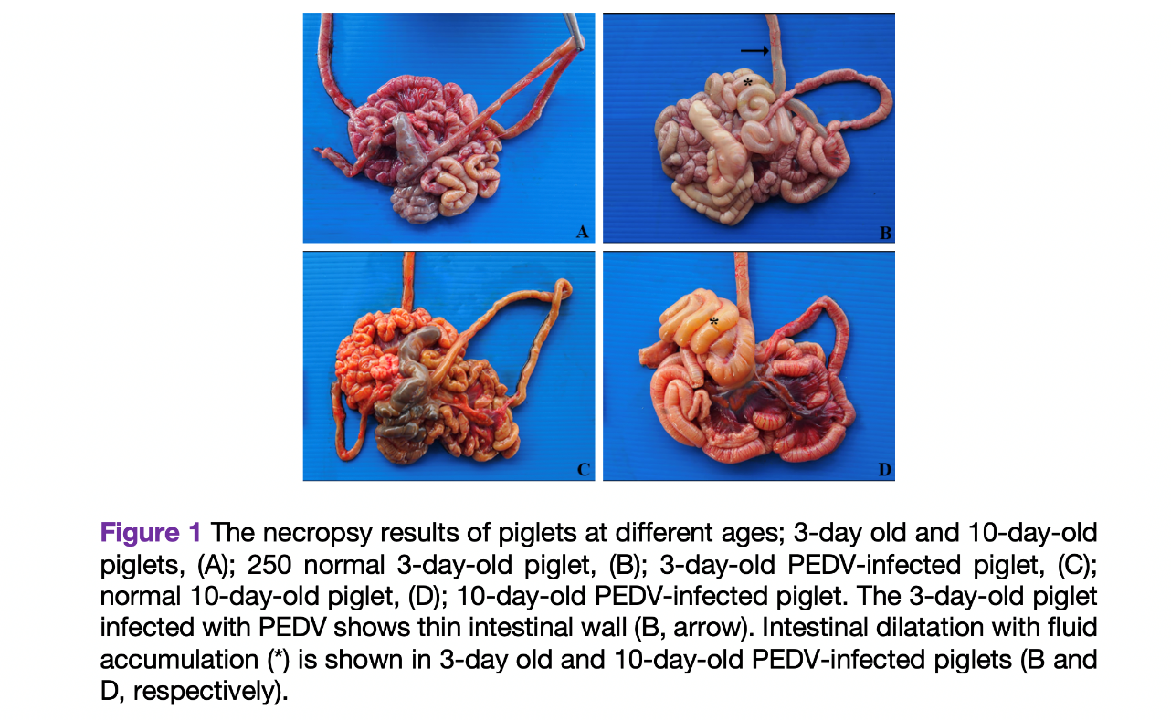
Table
- Tables should be created using the “Table” function in Microsoft Word. Please do not use Excel to insert tables as figures.
- Table captions and contents in the tables must be written clearly.
- Numbers and table headings must be placed above the table.
- Footnotes must be placed below the table; these may be used to explain abbreviations.
- Include units in column and row headings in parentheses.
- Tables must fit on a single 21.6 x 28 cm page with 2.5 cm margins.
- Vertical table lines should be avoided; horizontal lines should be used to separate topics from content.
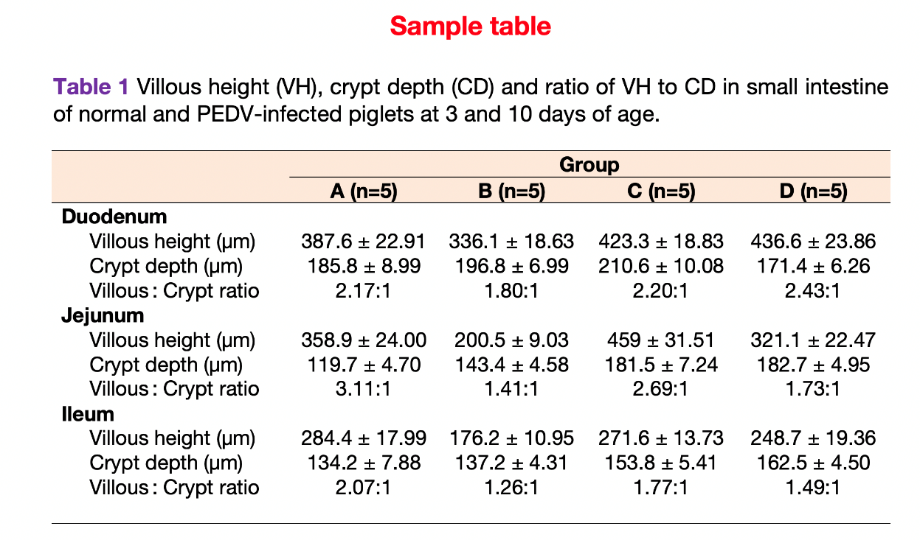

References
The name-year system should be employed for in-text citations. All referenced documents should be in English. If referenced documents are in other languages, the author must translate them into English. Authors are welcome to use reference managers such as Endnote, Reference Manager, or Zotero, which can help to expedite the proofreading and publishing processes.
- All in-text citations must have corresponding citations in the reference list.
- The name-year system must be employed for in-text citations. For example, “Based on the study of Toyoki (2010), it was shown that…” or “… corresponding to the study in canines (Hirada, 2010), horse (Maki and Hida, 2011) which discovered the level….”
- If citing more than two author, the first author must be cited and followed by et al. For example, “… High level of Oct-4 gene expression was discovered in blastocyst (Nganvongpanit et al., 2006)”
- The Reference list should be presented in alphabetical order.
- References by the same author and same year of publication should be cited with a lowercase letter indicating the progression, for example, 2010a, 2010b.
- If referenced documents are not in English, they must be translated into English with permission granted by the authors of such documents.
- Studies that have been published but are undergoing preparation should be identified as “in press” at the end of the reference.
- Studies that have not been published cannot be used as references.
- Studies that are published online without volume and page numbers must be identified by the Digital Object Identifier (DOI).
- Sample references are listed below.
Journals
Maneepitaksanti, W., Worananthakij, W., Sriwilai, P., Laoprasert, T., 2014. Identification and distribution of gill monogeneans from Nile tilapia and red tilapia in Thailand. Chiang Mai Vet. J. 12, 57–68.
Tongkamsi, S., Singasa, K., Tubtim, T., Nakbubpa, K., Chansilpa, T., Kayee, S., 2015. Effects of storage time at 32.5 oC on amount of Bacillus cereus in UHT milk for school in Chonburi province. Chiang Mai Vet. J. 13, 1–6. (In Thai)
Conference reports
Caffrey, J.P., 1994. Status of bovine tuberculosis eradication programmes in Europe. In: Wood, P.R., Monaghan, M.L., Rothel, J.S. (Eds.), Bovine Tuberculosis. Vet. Microbiol. 40, 1–4.
Books
Armitage, P., Berry, G., 1987. Statistical Methods in Medical Research. Blackwell Scientific Publications, Oxford, pp. 94–100, 411–416.
AUTHOR INFORMATION PACK 4 Oct 2015 www.elsevier.com/locate/vetmic 12
Chapters from book
Butler, J.E., 1981. A concept of humoral immunity among ruminants and an approach to its investigation. In: Butler, J.E., Nielson, K., Duncan, J.R. (Eds.), The Ruminant Immune System, Plenum Press, New York, pp. 3–55.

